- Here I have a flywheel with 10kg/m^2 nodal inertia driven by a 100 Nm trapezoidal shape torque pulse of 0.005 sec followed by a 5 msec -10 Nm pulse.

- I am using the internal solver with Dynamic Response 3D

- I am using a 25mm dia steel shaft with 1.0m between the torque application point and the flywheel.

- The result is a 410 Hz ripple (T = 0.00244 sec). It even shows superimposed on the torque pulse.

- I am measuring the torque at x=10mm (close to the LH support).

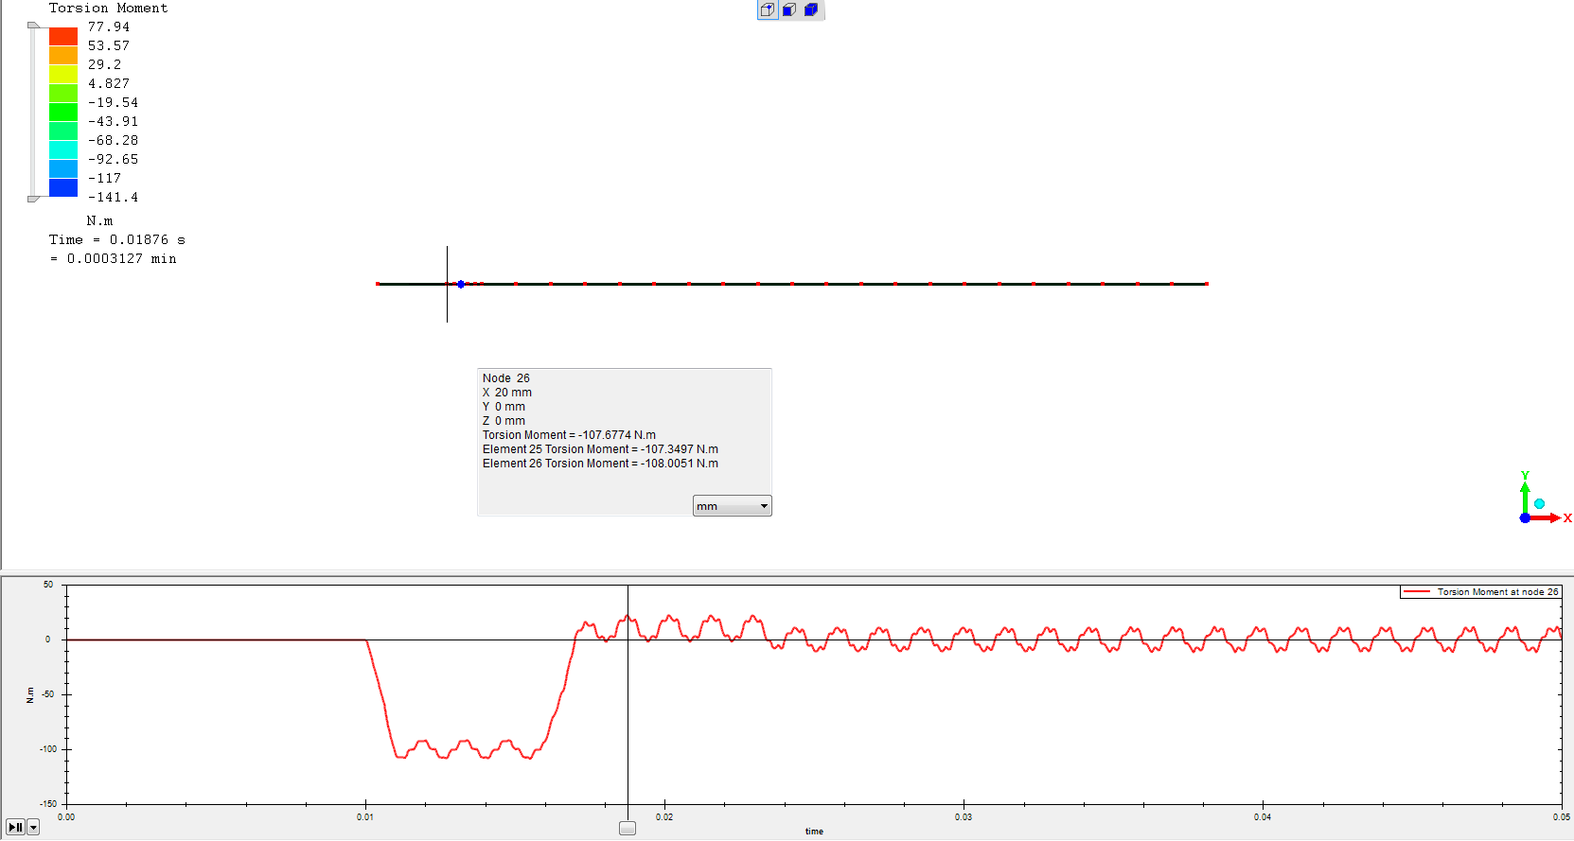

Below, we see that the ripple is 410 Hz with an amplitude of about 10 Nm (should be zero).
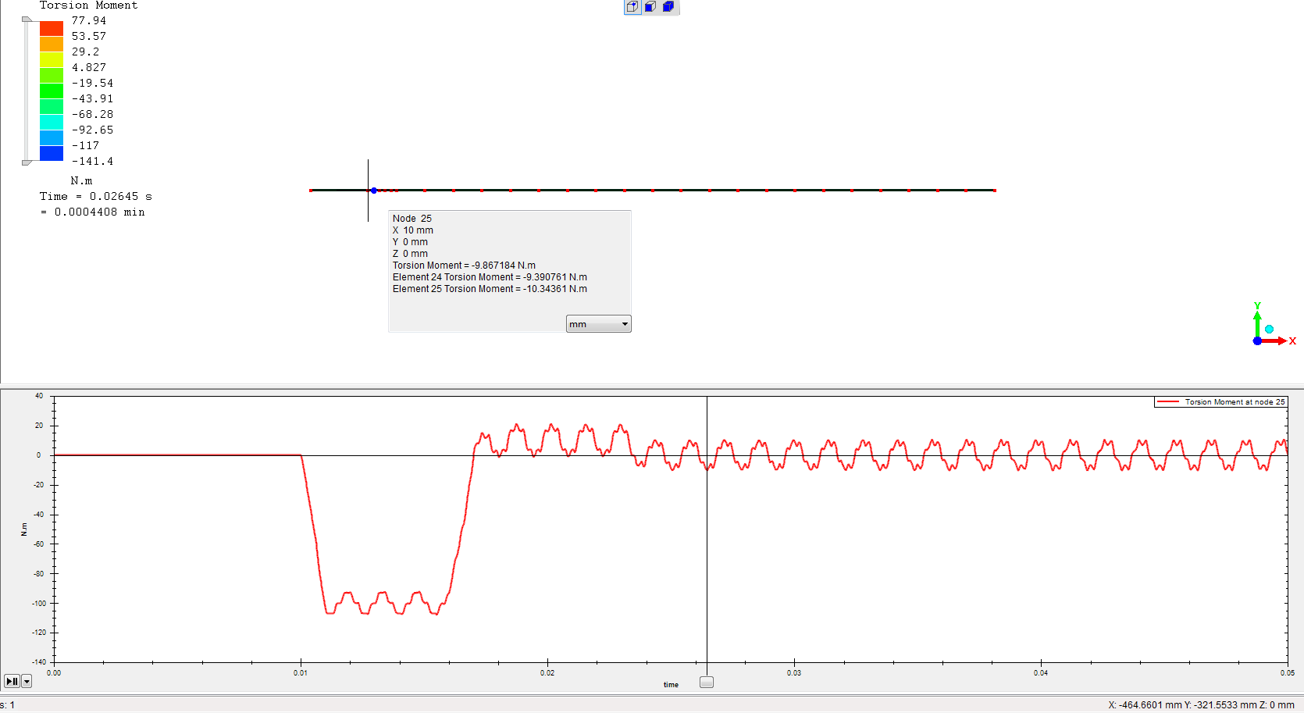

If you measure at x=950 mm and at t=40 msec, when the torque should be zero, we are still getting +- 60 Nm

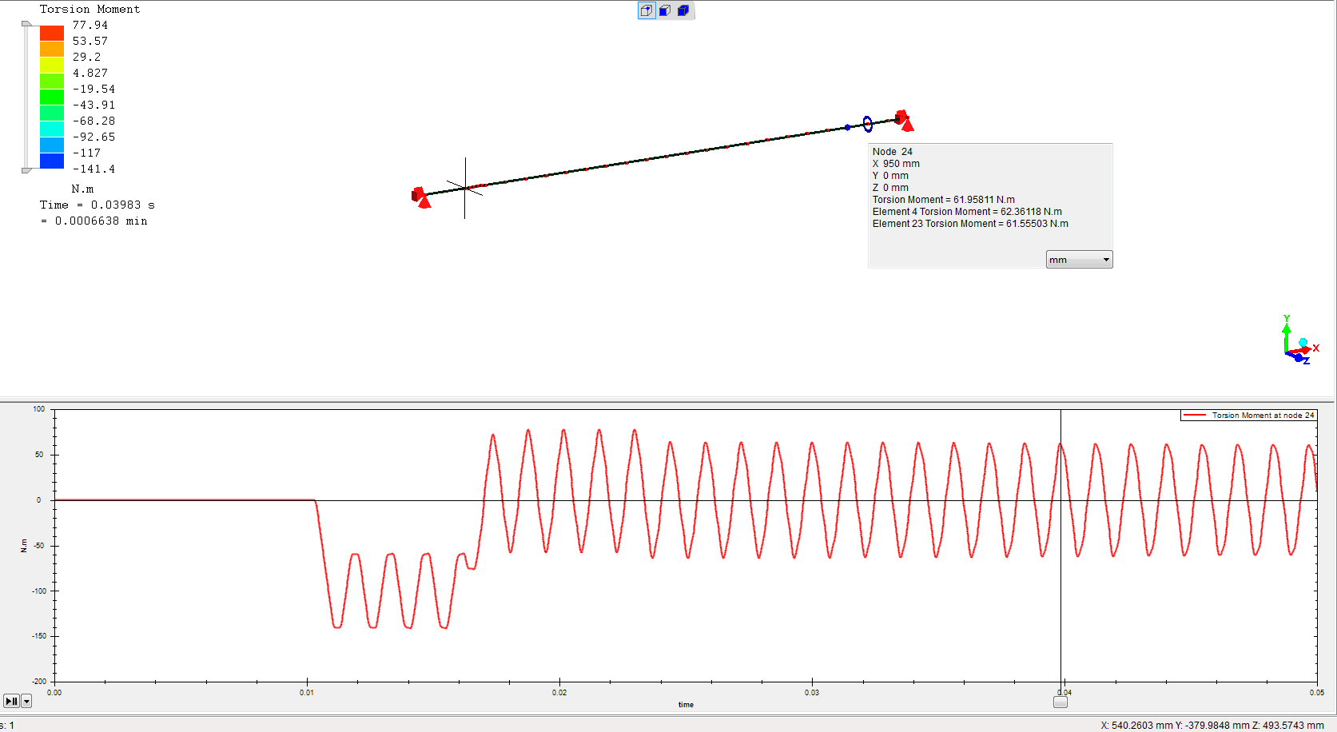

Below is a longer term shot at this
