This shows the angular velocity of the top shaft at node 1. At t=0.00187 sec, w = 149 rad/sec
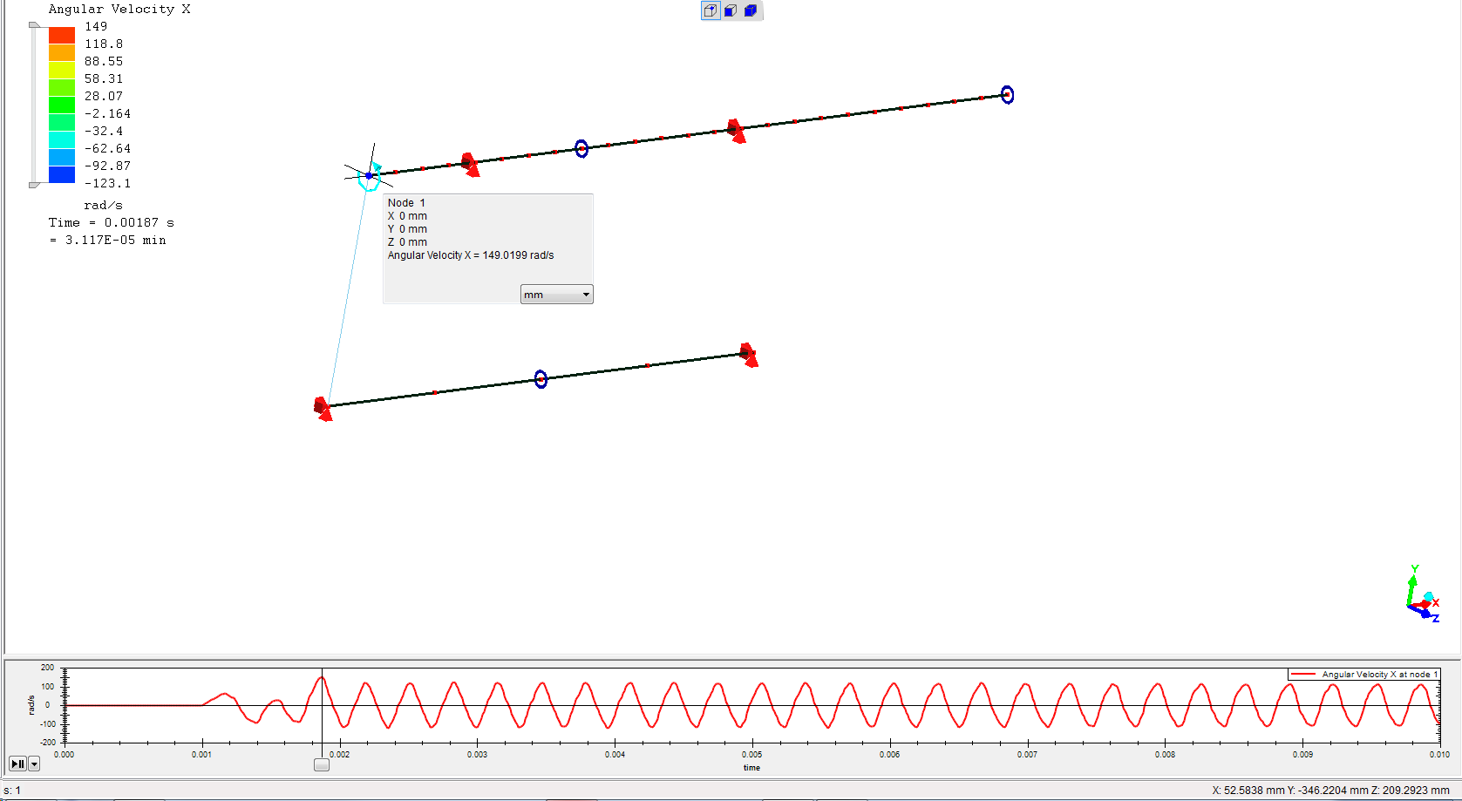

This shows the angular velocity of the bottom shaft at node 26. At t=0.00187 sec, w = 49.6 rad/sec, thus showing the 3:1 ratio between the 2 shafts.
